PHASE 6
Project Testing
Test Cases
ID | Test Case | Input | Expected Output | Actual Output | Result
TC01 | Register API | Valid name, email, password | User created, 201 response | As expected | Pass
TC02 | Login API | Valid registered email & password | JWT token returned, 200 response | As expected | Pass
TC03 | Login API | Invalid password | 401 Unauthorized error | As expected | Pass
TC04 | Create Blog API | Valid title, content, category + JWT | Blog created, 201 response | As expected | Pass
TC05 | Fetch Blogs API | GET request to /api/blogs | List of blogs returned, 200 response | As expected | Pass
TC06 | AI Generate Blog API | Valid topic + category | AI-generated title & content returned, 201 response | As expected | Pass
TC07 | AI Summarize API | Valid blog content | Concise AI-generated summary returned, 200 response | As expected | Pass

Bugs Found and Fixes
Bug | Fix
Login succeeded even with missing JWT secret configured, returning a malformed token | Added environment variable validation on server startup and a check in the auth controller before signing tokens
Duplicate email allowed on registration | Added a unique index and pre-save validation on the email field in the User schema
Gemini AI service failure crashed the generate-blog request | Wrapped the Gemini AI call in try/catch with a graceful fallback error response
Unauthenticated users could call the Create Blog endpoint | Added JWT verification middleware to protect the /api/blogs POST route

Final Testing Screenshots
Register API

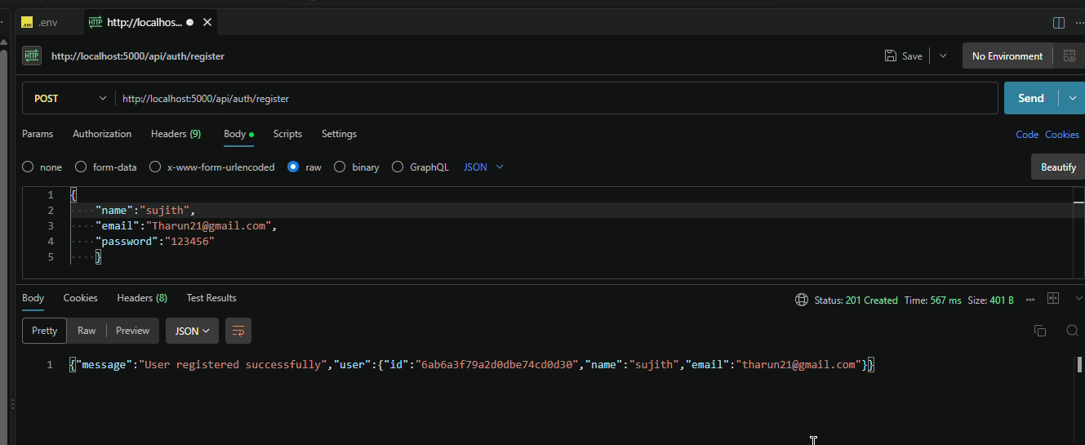
Fig 6.1 -- Register API tested in Postman

Login API
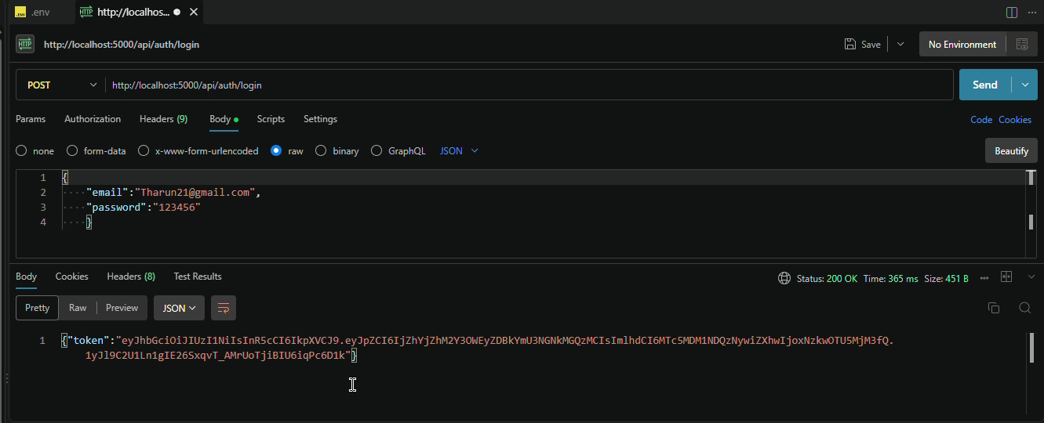
Fig 6.2 -- Login API tested in Postman

Create Blog API

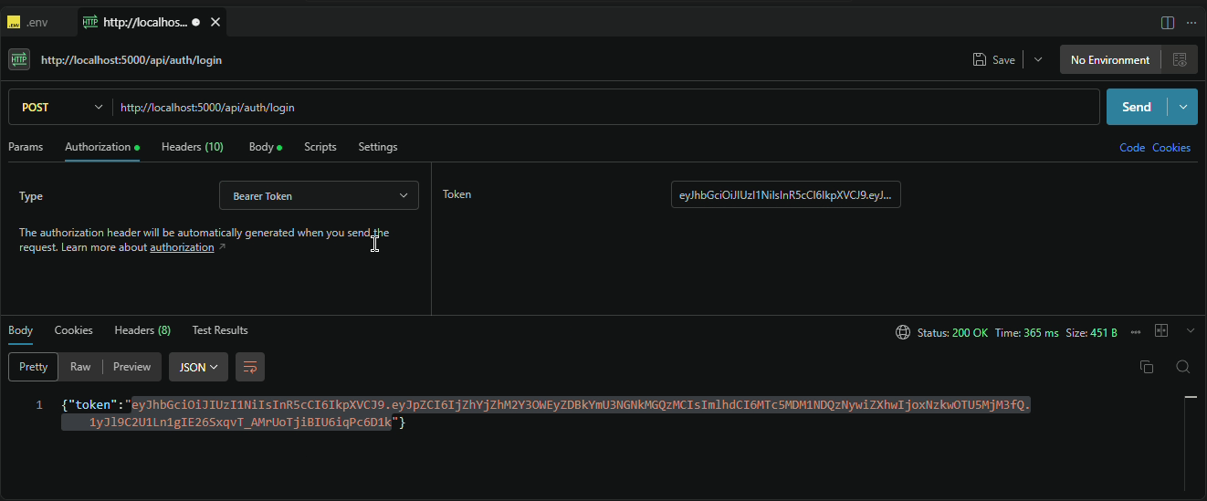
Fig 6.3 -- Create Blog API tested in Postman
Fetch Blogs API

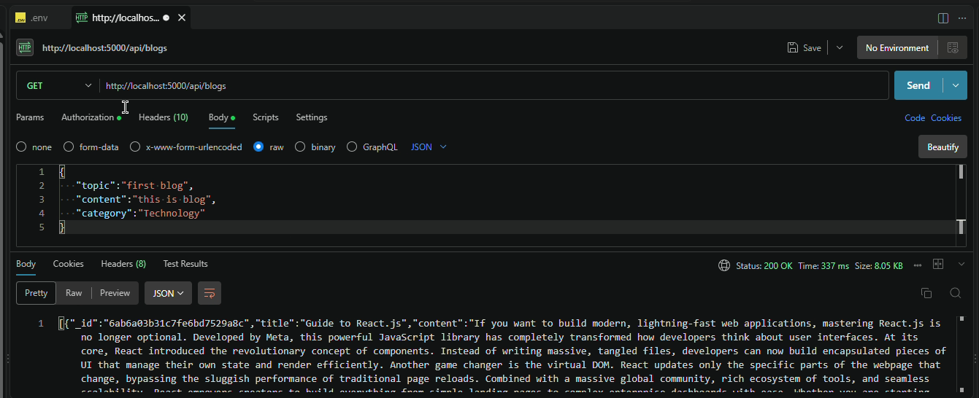
Fig 6.4 -- Fetch Blogs API tested in Postman

AI Generate Blog API

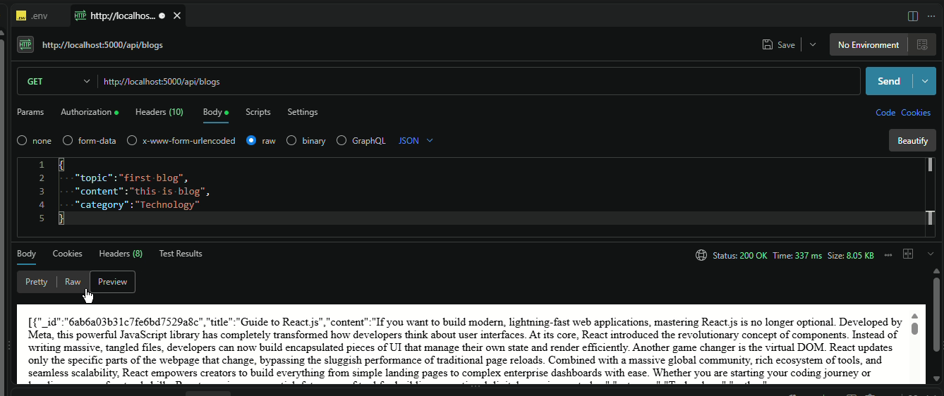
Fig 6.5 -- AI Generate Blog API tested in Postman
AI Summarize API
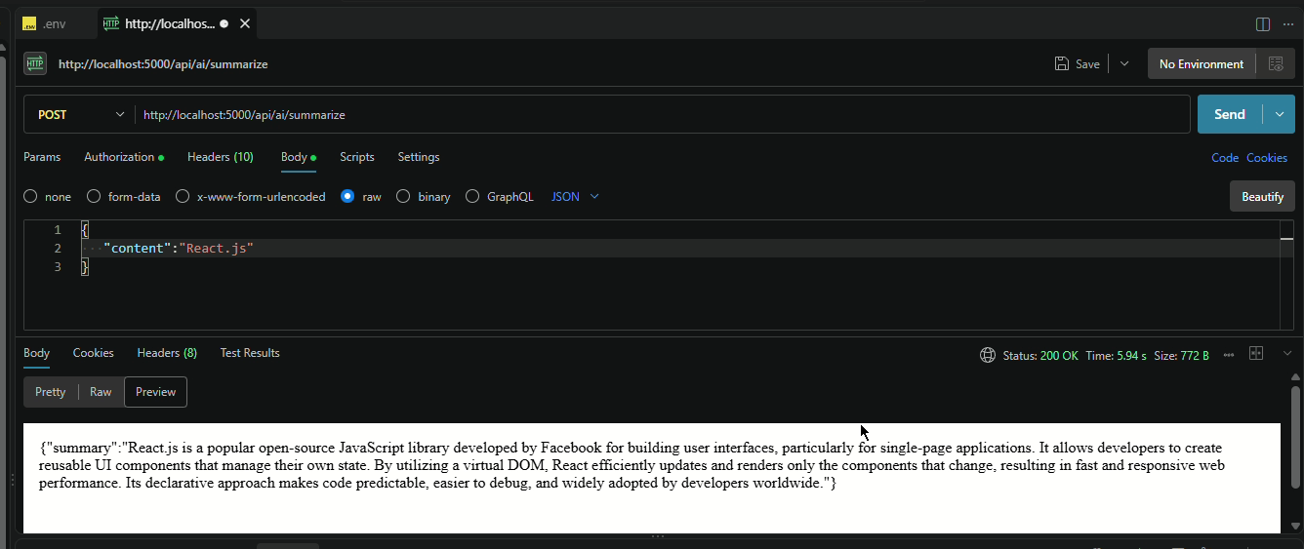
Fig 6.6 -- AI Summarize API tested in Postman

